STM32F103 Microcontroller Info:

From this website, the microcontroller is the same the maple and maple mini use, so it should be possable to program this with the Arduino IDE, thou it will probably take jumping though some hoops to get it done.

<http://www.rogerclark.net/stm32f103-and-maple-maple-mini-with-arduino-1-5-x-ide/>

<http://leaflabs.com/>

<https://github.com/bobc/maple-asp>

This is the board I have (not a offical maple board but it may still work the same reading from the sites above)

# **ARM Cortex-M3 STM32F103C8T6 STM32 Minimum System Development Board**

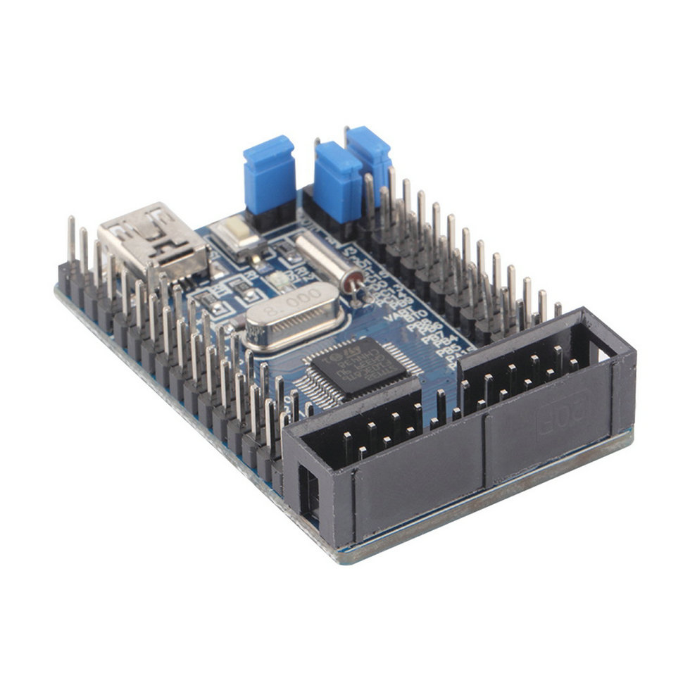

Description:

1. Chip board STM32F103C8T6

2. Board JTAG interface and reset button

3. The onboard crystal 32.768KHZ and 8MHZ

4. With 5V to 3.3V chip AMS1117-3.3

5. With a group of UART serial interfaces

6. All I/O all the leads, and mark the I/O name

7. On-board Mini USB interface, you can give the board power supply and USB communication

8. Board size 52.1 (mm) x35.5 (mm)

Package:

1x ARM Cortex-M3 STM32F103C8T6 STM32 Minimum System Development Board

Russian Website with lots of Information:

<https://m.geektimes.ru/post/255796/>

Other Websites:

<http://www.sillybytes.net/2016/09/gentle-introduction-to-stm32-arm-cortex.html>